ALLURE GRAY LENSES

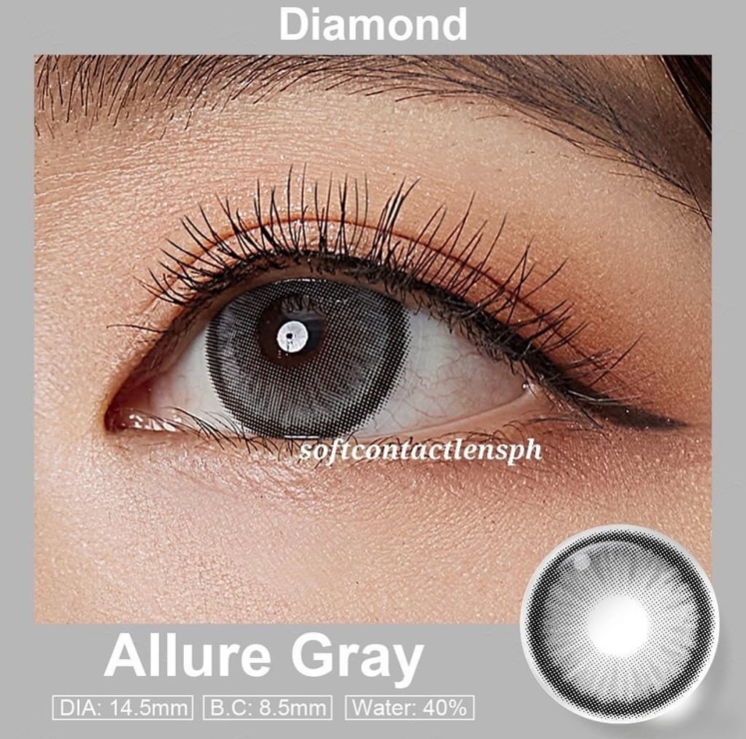

**DIA: 14.5mm**

**B.C: 8.5mm**

**WATER: 40%**

Allure Gray contact lenses are a type of colored contact lenses that offer a gray color option. These lenses are designed to enhance or change the natural eye color, providing a unique and captivating appearance. The gray shade of these lenses can range from a subtle and natural-looking gray to a more intense and dramatic gray, depending on the desired effect. Allure Gray contact lenses are made with advanced technology to provide a natural and realistic gray eye color. They are typically made from high-quality materials that allow for comfortable and safe wear throughout the day. These contact lenses are available in different designs and patterns to mimic the natural variations found in real eyes, resulting in a more authentic and captivating look. Some designs may feature a blend of different shades of gray, while others may have a subtle limbal ring to enhance the appearance of the iris. It is important to note that Allure Gray contact lenses, like any other contact lenses, require proper care and maintenance. They should be cleaned and stored according to the instructions provided by the manufacturer or your eye care professional. It is also crucial to follow the recommended wearing schedule and replace the lenses as directed to maintain eye health and prevent any potential complications. Before using Allure Gray contact lenses or any other colored contact lenses, it is essential to consult with an eye care professional. They can assess your eye health, determine the correct fit, and provide guidance on proper usage and care. Remember, the safety and well-being of your eyes should always be a top priority when using contact lenses.